A2011-Eur-England-Kent-Northfleet near Swanscombe-Clactonian Hand Axe- 424,000 – 400,000 BP



Fig. 1. England-Kent-Northfleet near Swanscombe-Clactonian Hand Axe

**Formal Label:** England-Kent-Northfleet near Swanscombe-Clactonian Hand Axe

**Case Description:**

Clactonian refers to the flint tools found in a paleo-channel at Clacton-on-Sea in Essex, England, in 1911 (Warren 1922). The present tool was found in the Northfleet area, near the destroyed flint quarries of Barnfield Pit and Rickson's Pit, Swanscombe, Kent County, England, previously noted for their Clactonian artifacts (Tester 1984).

This rare Clactonian hand Axe dates to  424,000 – c. 400,000 BP and was made by Homo Heidelberghensis (Homo erectus) (McNabb 2007) on a cordiform or heart-shaped flint nodule. It has a simple bilateral symmetry to form a robust distal point. The proximal end has also had bifacial working to one edge. It has a patination that shows a very ancient sheen, and it was shaped from a cobble where some of the original cortex is still visible.

**Accession Number: 2011**

**LC Classification:** GN772.22.G7

**Date or Time Horizon:** 424,000 – 400,000 BP

**Geographical Area:** Northfleet near Swanscombe, Kent

**Map, GPS Coordinates:** 0.33694, 51.441072; 51° 26' 27.859" N 0° 20' 12.984" E.

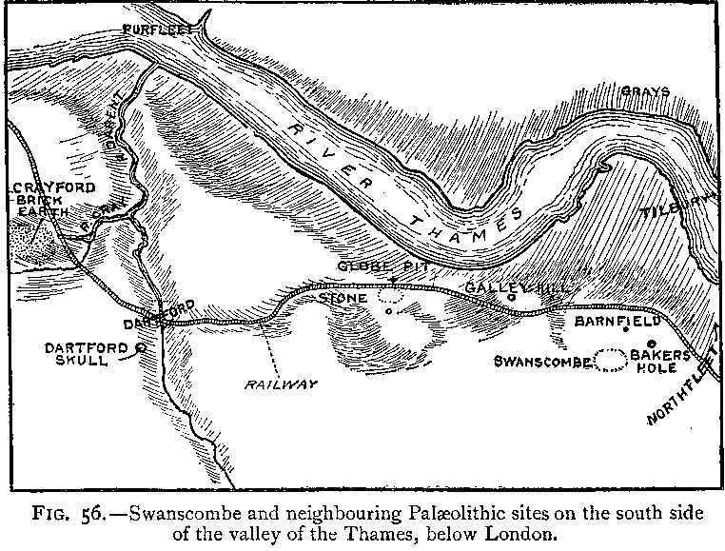

Fig.3. “Swanscombe and neighboring paleolithic sites on the south side of the valley of the Thames, below London,” after Keith 1916, Fig. 56.

Fig. 4. Map of Swanscombe and Northfleet on the south side of the valley of the Thames, below London, up to 1996, where Paleolithic peoples sought flint in the chalk outcrops and areas of quarries. After [LinguisticDemographer](https://en.wikipedia.org/wiki/User:LinguisticDemographer) at [English Wikipedia](https://en.wikipedia.org/wiki/).

**Cultural Affiliation:** Lower Paleolithic, Clactonian

**Medium:** flint.

**Dimensions: H 4.99 in, 126.98 mm  
Weight: 1 lb, 2.75 oz; 532 gm**

**Provenance: found in the** Northfleet Area east of Swanscombe.

**Condition:** original.

**Discussion:**

Clactonian flint tools were made by *Homo erectus* in the early Hoxnian Interglacial, ca 400,000 BP (Marine Isotope Stage 11, 424,000-374,000 BP (Lisiecki and Raymo 2005; Stringer 2006) and may have been used for hunting Pleistocene animals including the straight-tusked elephant *(Palaeoloxodon antiquus*) (Glass 2016) and the giant hippopotamus, (Hippopotamus amphibius) (Schreve 2009**;** Tester 1984). Clactonian refers to the flint tools found in a paleo-channel at Clacton-on-Sea in Essex, England, in 1911 (Warren 1922).

This tool was found in Northfleet, near the destroyed flint quarries of Barnfield Pit and Rickson's Pit, Swanscombe, Kent County, England, previously noted for their Clactonian artifacts (Darvill, 30 Jan 2017; Tester 1984). Clactonian tools evolved from Olduwan tools that are associated with *Australopithecus afarensis* (“Lucy”), but unlike Olduwan tools, some Clactonian tools are side-notched, like the side-scraper (above) indicating they were hafted to a handle or shaft. Retouch on Clactonian tools is uncommon, but the side-scraper (above) exhibits retouching both to make it sharper and to make it possible to haft it to a handle with two larger, opposing side-notch flakes. The prominent bulb of percussion on the flakes indicates use of a hammerstone for more controlled and regulated shapes than was possible with the Olduwan technology.

**References:**

Conway, Bernard, John McNabb and Nick Ashton, eds.. 1996. *Excavations at Barnfield Pit, Swanscombe, 1968-72*; illustrations by Phil Dean. London: Dept. of Prehistoric and Romano-British Antiquities.

Darvill, J. 2017. Pers. comm. 30 Jan. 11, ME19 5LH, UK.

Glass, Helen. 2004. “Stone Age elephant remains found,” BBC News, 19 June. [http://news.bbc.co.uk/2/hi/uk_news/england/kent/3821527.stm. Retrieved 1 Feb 2017](http://news.bbc.co.uk/2/hi/uk_news/england/kent/3821527.stm.%20Retrieved%201%20Feb%202017).

Keith, Arthur. 1915. *The Antiquity of Man.* London.

Lisiecki, Lorraine E. and Maureen E. Raymo. 2005. ["A Pliocene-Pleistocene stack of 57 globally distributed benthic δ18O records"](http://www.lorraine-lisiecki.com/LR04_MISboundaries.txt). <http://www.lorraine-lisiecki.com/LR04_MISboundaries.txt>. Retrieved 1 Feb 2017.

McNabb, John. 2007. *The British Lower Palaeolithic: stones in contention*. London, New York: Routledge.

Schreve, Danielle C. 2009. “A new record of Pleistocene hippopotamus from River Severn terrace deposits, Gloucester, UK—palaeoenvironmental setting and stratigraphical significance*,” Proceedings of the Geologists' Association*, 120 (1): 58–64.

Stringer, Chris. 2006. *Homo Britannicus: The incredible story of human life in Britain.* London: Penguin.

Tester, P. J. (1984). "Clactonian Flints from Rickson's Pit, Swanscombe," *Archaeologia Cantiana, Kent Archaeological Society*. Retrieved 1 Feb 2017.

Warren, S. H. 1922. “The Mesvinian Industry of Clacton-on-Sea,” *Proceedings of the Prehistoric Society of East Anglia*, 3: 597-602.